**EDUCATIONAL ORGANIZATION USING SERVICE NOW**

**Project Description**

The project aims to develop a comprehensive **educational institution management system using ServiceNow**. This system will enable students, staff, and administrators to efficiently manage academic and administrative activities. It will include features such as a student portal for accessing academic resources, timetable scheduling, digital ID management, and family member access for monitoring student progress. Leveraging ServiceNow’s powerful workflow automation and cloud capabilities, the system will ensure a seamless user experience, secure data handling, and scalability to support institutions of various sizes. The goal is to streamline institutional operations, enhance transparency, and improve overall academic and administrative efficiency.

**Project Flow**

Milestone 1: Setting up service now instance.

Milestone 2: Creation of new update set.

Milestone 3: Creation of table.

Milestone 4: Forming a Layout.

Milestone 5: Forming a design.

Milestone 6: Number Maintenance.

Milestone 7: Process Flow.

Milestone 8: Client Script.

Milestone 9: Result.

**Milestone 1: Setting Up ServiceNow Instance**

1. Sign up for a developer account on the ServiceNow Developer site “https://developer.servicenow.com”.

Once logged in, navigate to the "Personal Developer Instance" section.

1. Click on "Request Instance" to create a new ServiceNow instance.
2. Fill out the required information and submit the request.
3. You'll receive an email with the instance details once it's ready.
4. Log in to your ServiceNow instance using the provided credentials.
5. Now you will navigate to the ServiceNow.

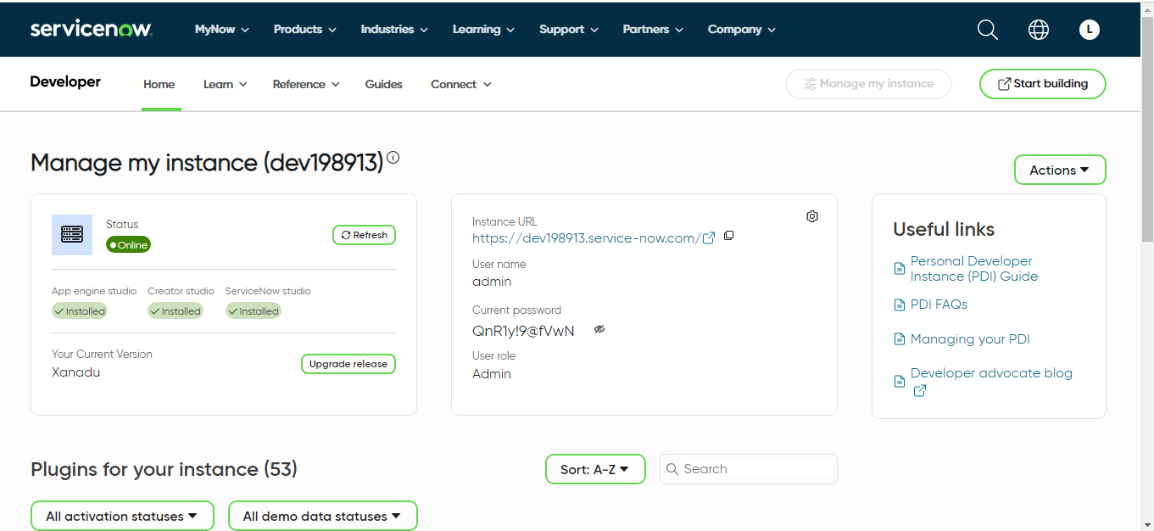

**Milestone 2: Creation Of New Update Set**

1. Click on All >> Local update sets .

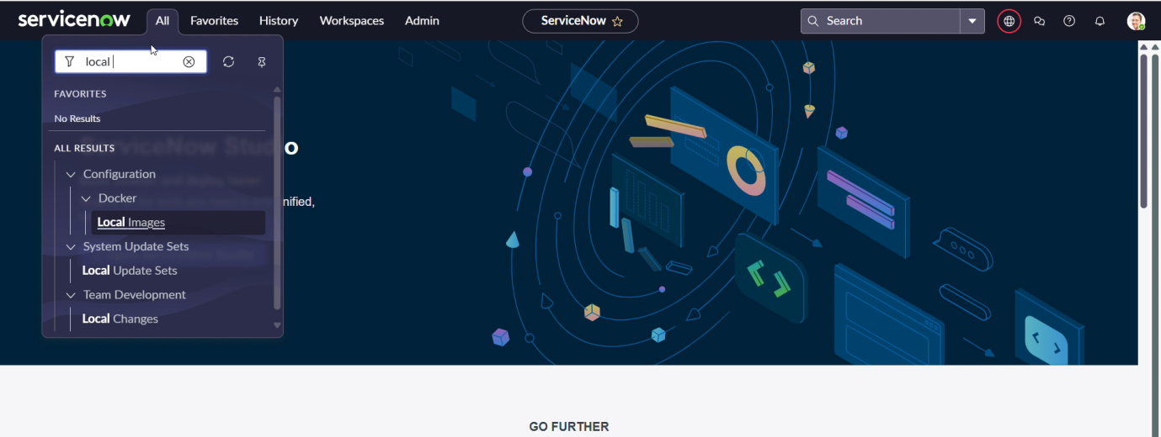

2. Click on new

3. Enter the Details Name: Educational Organisation >> Click on Submit and make Current.

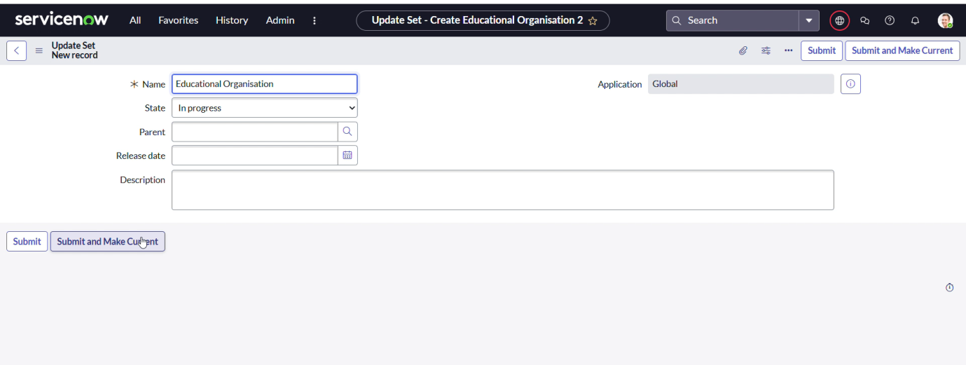

**Milestone 3: Creating a Table**

**Creating Salesforce Table**

All >> Tables.

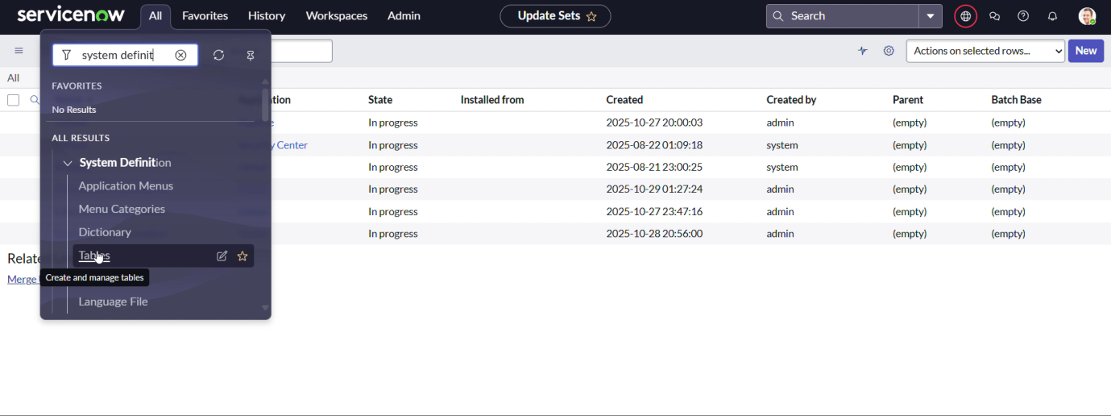

Click on new

Enter the Label(Anything you want): Salesforce >> Click on Name it will Automatically generate Api name.

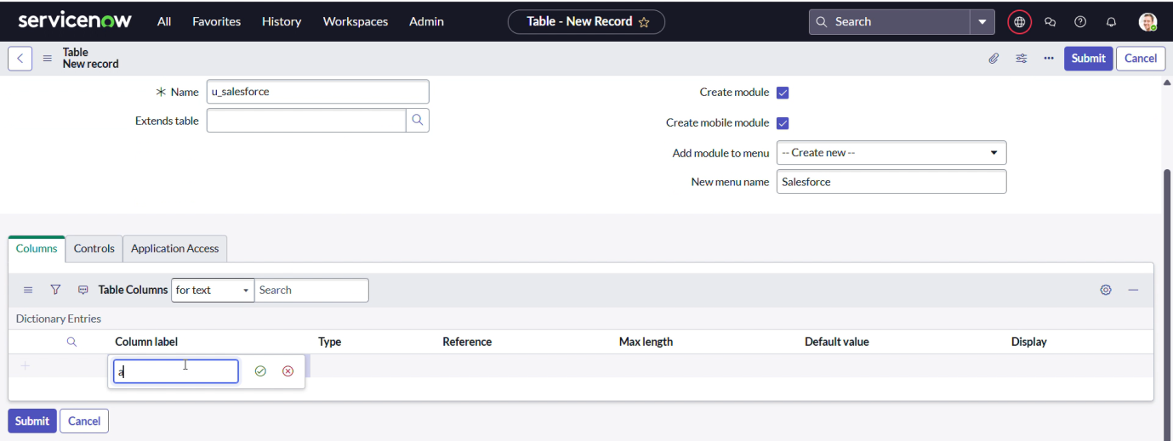

Create columns as given below,Double Click on Column label and Enter the Column labels and click on the tick mark >> Give Type as given .

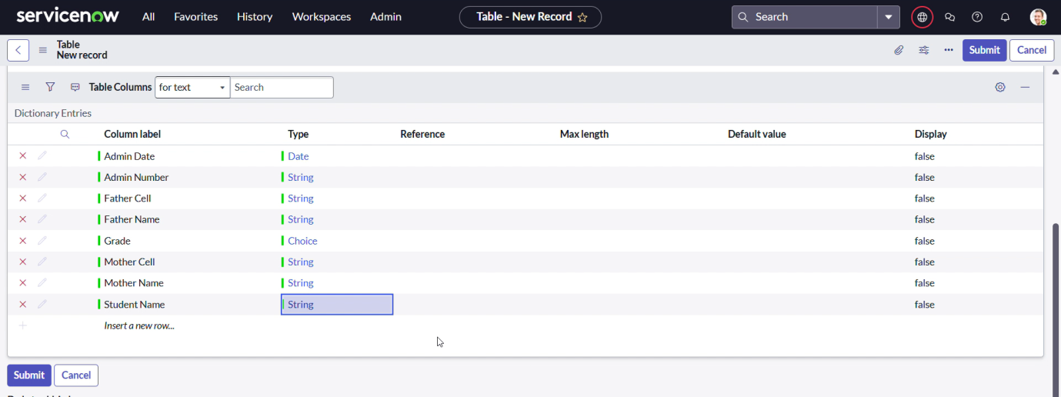

For “Admin Number” Give Display as True and right click on the toggle bar on top >> save.

Click on controls >> Enable Extensible.

Click on “Admin Number” column, In Related Links Click on Advanced View >> Default View (Enable Use dynamic default) >> select Get Next Padded Number in Dynamic default value >> Update .

Click on “Grade” Column >> Click on Choices and give Label,Value and Sequence as given below.

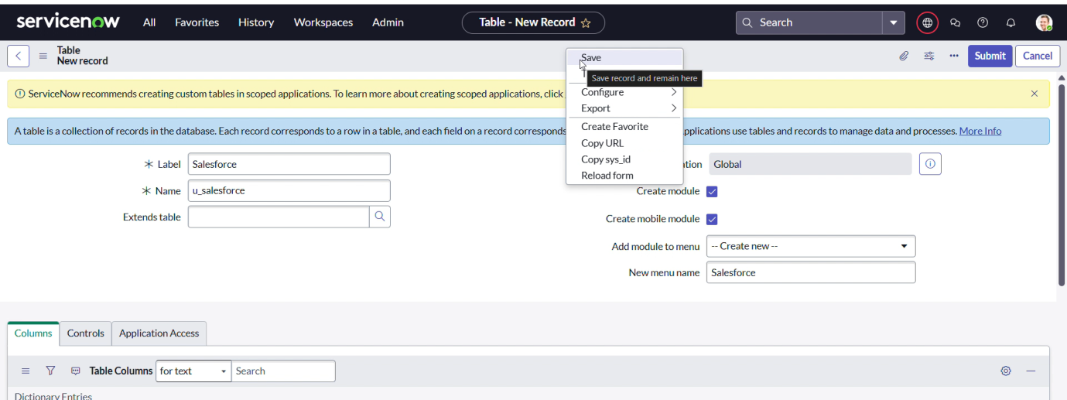

**Creating Admission Table**

Create an Admission Table with Columns given.

Select Extends Table >> Salesforce and also Select Add module to menu >> Salesforce.

Create Fields as shown

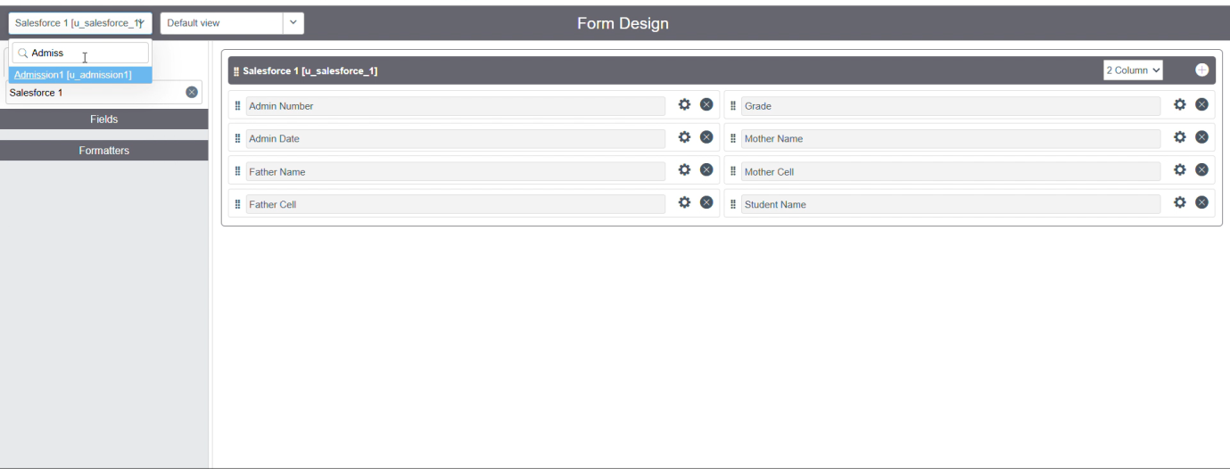

Create choice for Admin Status as:

Create choice for Pincode as:

Create choice for Purpose of Join as:

Create choice for School as:

Create choice for School Area as:

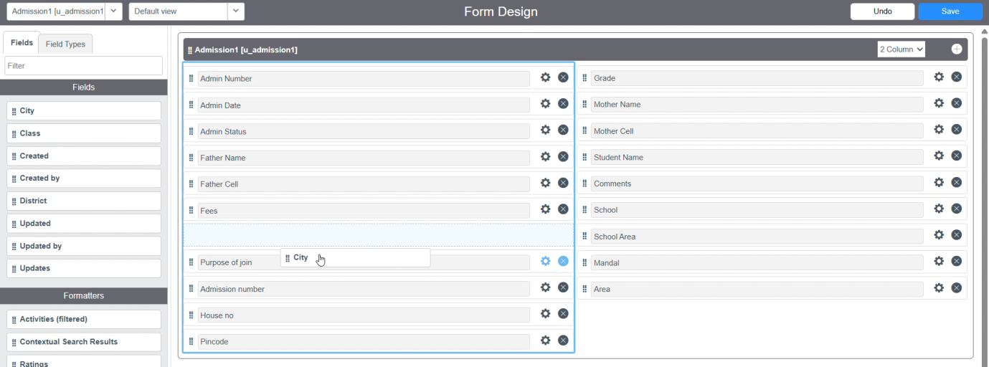

Create a Student Progress Table with Columns given.

Select Add module to menu >> Salesforce.

Create Fields as shown:



**Milestone 4: Forming a Layout**

1. In the Student Progress Table Page , Click on Layout form .



1. Click on Admission Number [+] .



1. Select below Admission Number fields in Available side and send it to selected side as below >> save.

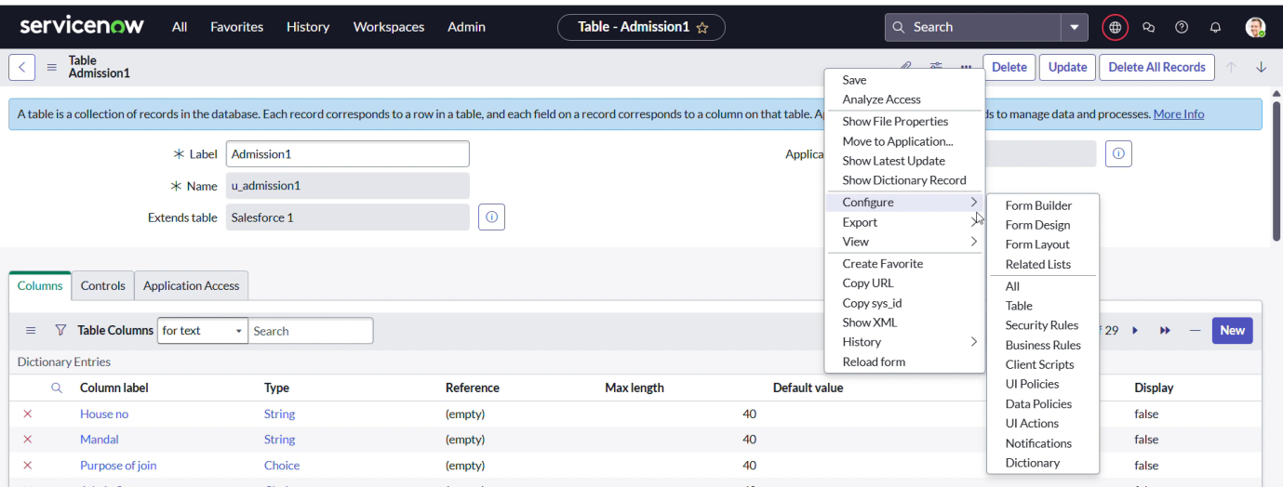

**Milestone 5: Forming a design**

1. All >> System Definition >> Tables .
2. In Label Search for Salesforce and open .
3. Right Click on top Toggle >> Configure >> Form Design.



1. In drop down select Salesforce(u_salesforce).

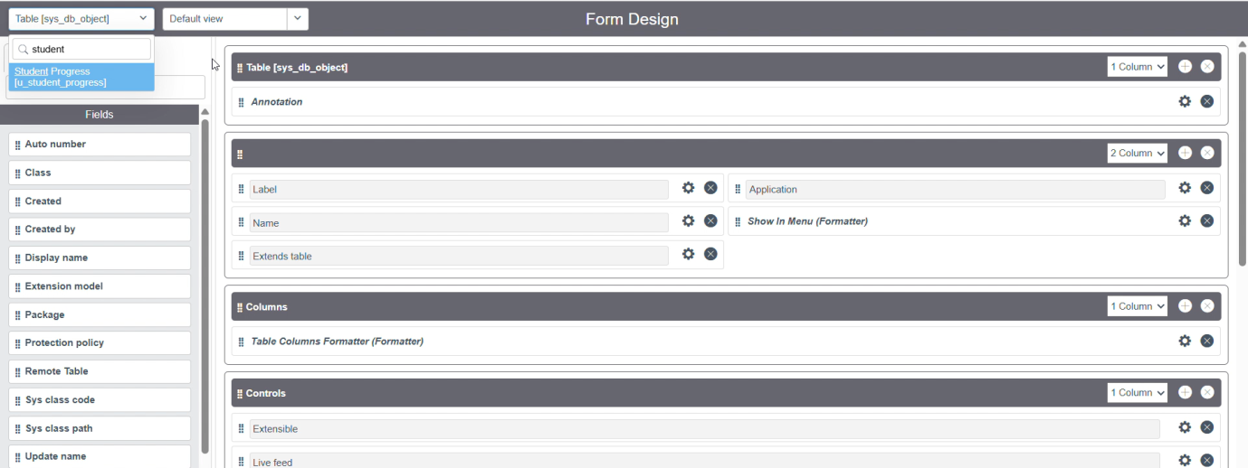

1. Drag and drop the fields to the left side as below.

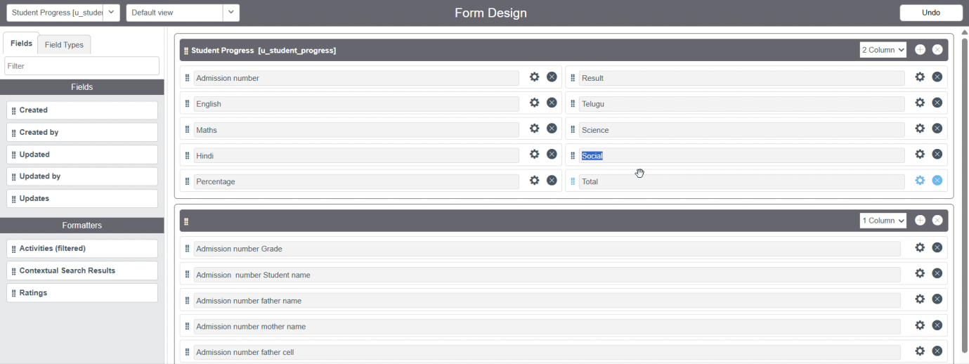

6. Save

7. Follow the same steps as Activity1, Configure the fields

**Milestone 6: Number Maintenance**

1. All >> Number Maintenance >> New

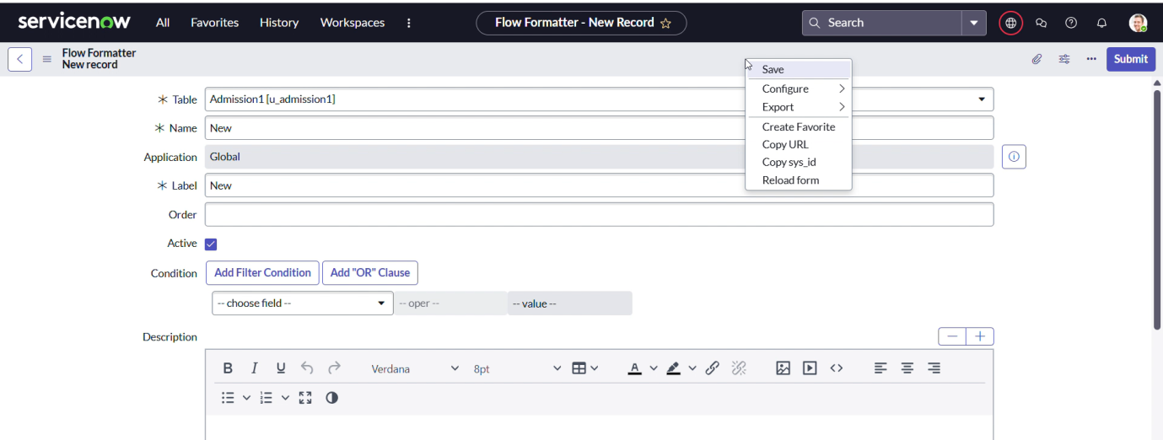

1. Fill the details >> Submit.

**Milestone 6: Number Maintenance**

1. All >> Process Flow>> New.

2. Fill the Details as given Below

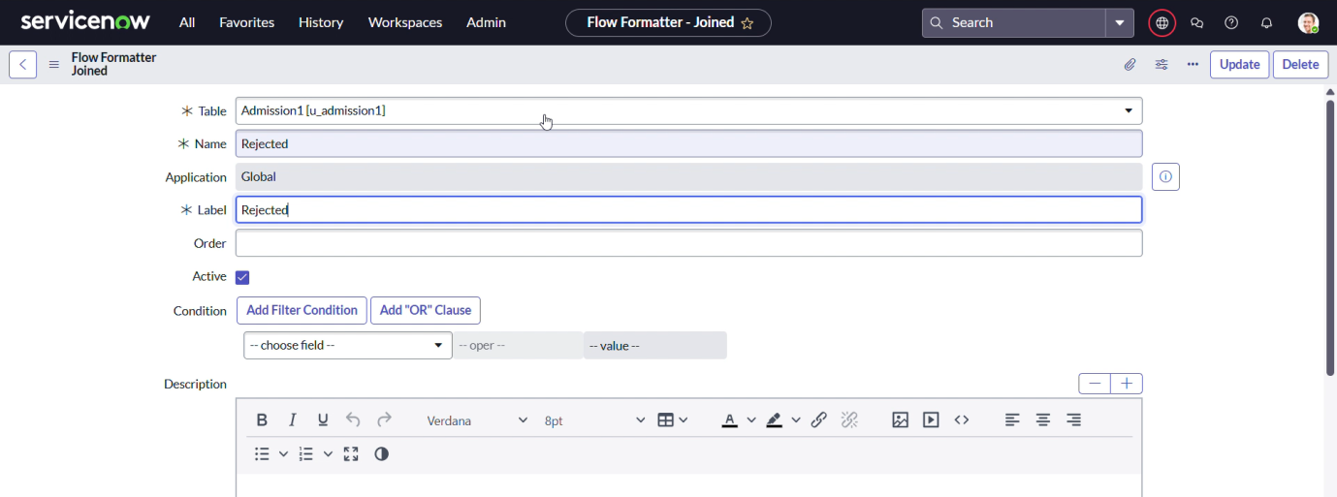

1. Right Click on toggle and click on the save .
2. Replace the Name and Label as below and click on Insert on stay.

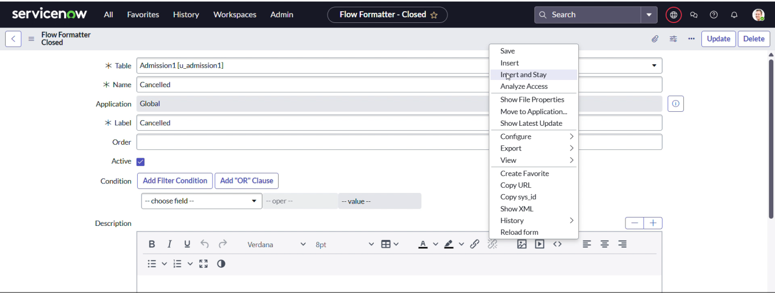

5.Replace the Name and Label in order and click on Insert on stay.

Joined >> Rejected >> Rejoined >> Closed >> Cancelled.

6.Order should be New >> InProgress >> Joined >> Rejected >> Rejoined >>Closed >> Cancelled.

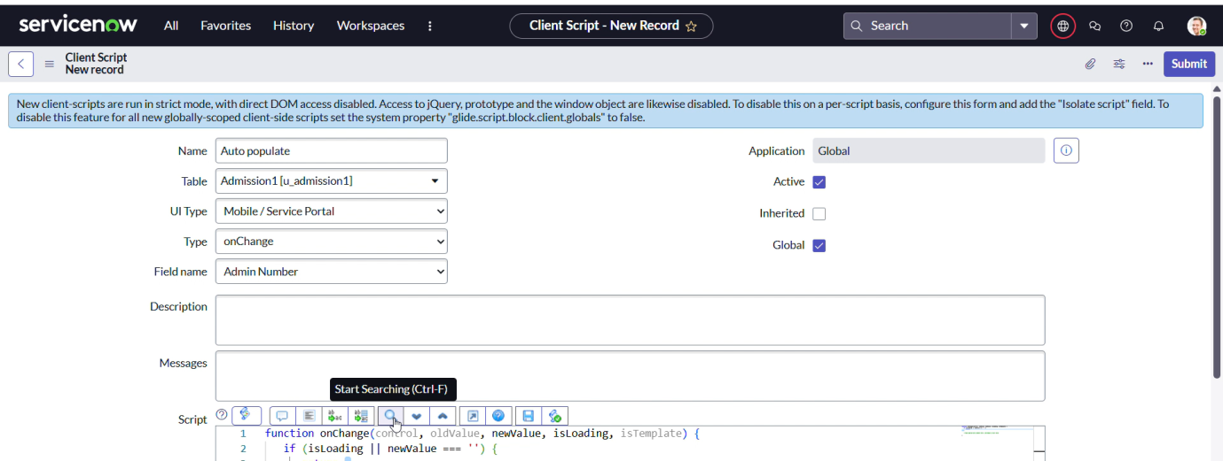

**Milestone 7: Client Script**

1. All >> Client Scripts >> New.
2. Fill the Details as given.

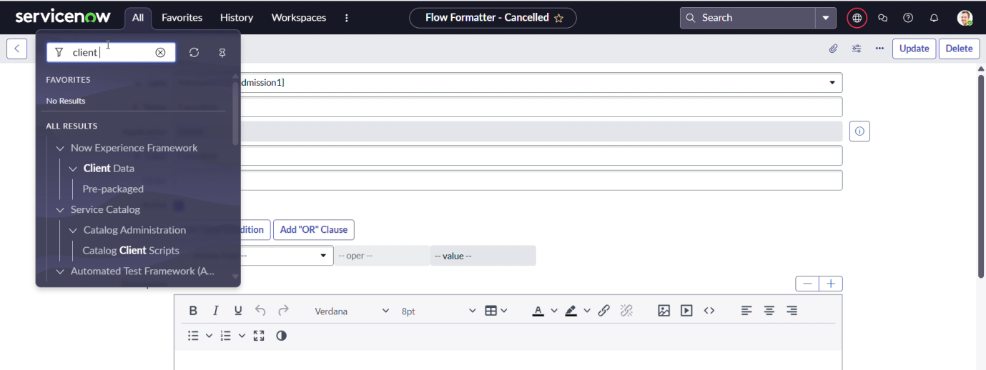

1. Write the Code as below, Enable Isolate script and Save.

function onChange(control, oldValue, newValue, isLoading, isTemplate) {

   if (isLoading || newValue === '') {

      return;

   }

   //Type appropriate comment here, and begin script below

   var a = g_form.getReference('u_admission_number');

   g_form.setValue('u_admin_date',a.u_admin_date);

   g_form.setValue('u_grade',a.u_grade);

   g_form.setValue('u_student_name',a.u_student_name);

   g_form.setValue('u_father_name',a.u_father_name);

   g_form.setValue('u_mother_name',a.u_mother_name);

   g_form.setValue('u_father_cell',a.u_father_cell);

   g_form.setValue('u_mother_cell',a.u_mother_cell);

   g_form.setDisabled('u_admin_date',a.u_admin_date);

   g_form.setDisabled('u_grade',a.u_grade);

   g_form.setDisabled('u_student_name',a.u_student_name);

   g_form.setDisabled('u_father_name',a.u_father_name);

   g_form.setDisabled('u_mother_name',a.u_mother_name);

   g_form.setDisabled('u_father_cell',a.u_father_cell);

   g_form.setDisabled('u_mother_cell',a.u_mother_cell);

}

1.Fill the Details as given.

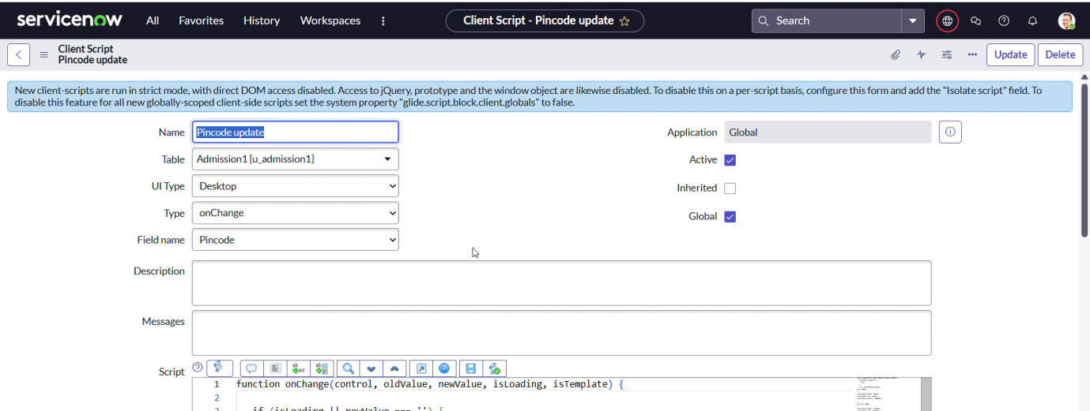

2. Write the Code as below, Enable Isolate script and Save.

function onChange(control, oldValue, newValue, isLoading, isTemplate) {

   if (isLoading || newValue === '') {

      return;

   }

    var a = g_form.getValue('u_pincode');

if(a == '509358')

{

g_form.setValue('u_mandal', 'kadthal');

g_form.setValue('u_city', 'kadthal');

g_form.setValue('u_district', 'RangaReddy');

}

else if(a == '500081')

{

g_form.setValue('u_mandal', 'karmanghat');

g_form.setValue('u_city', 'karmanghat');

g_form.setValue('u_district', 'RangaReddy');

}

else if(a == '500079')

{

g_form.setValue('u_mandal', 'Abids');

g_form.setValue('u_city', 'AsifNagar');

g_form.setValue('u_district', 'Hyderabad');

}

1.Fill the Details as given.

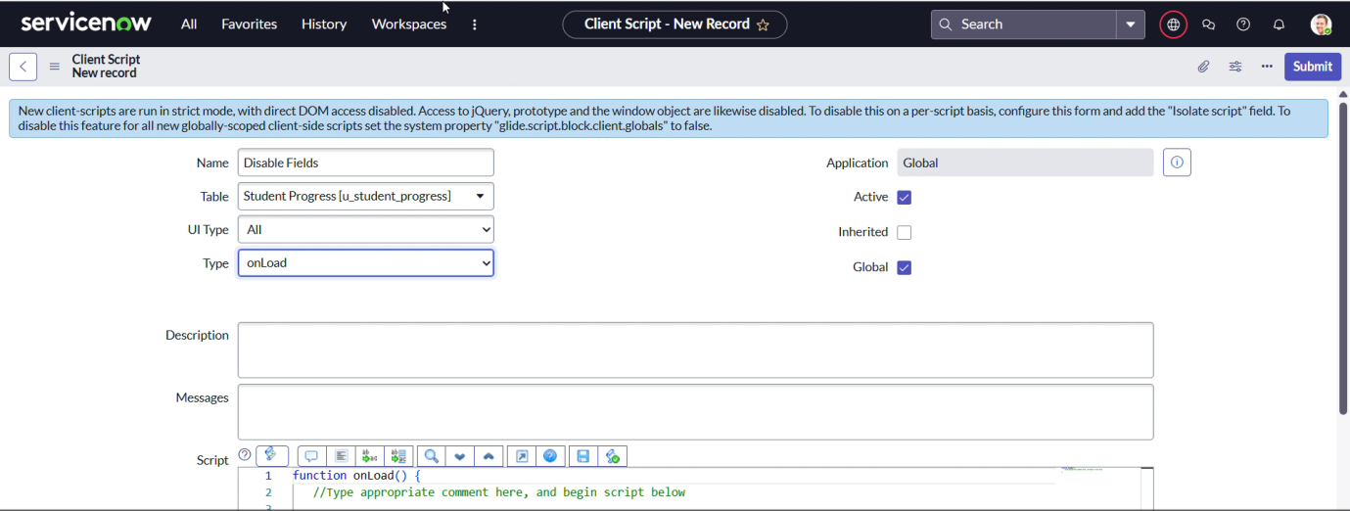

1. Write the Code as below, Enable Isolate script and Save.

function onLoad() {

   //Type appropriate comment here, and begin script below

   g_form.setDisabled('u_total',true);

   g_form.setDisabled('u_percentage',true);

   g_form.setDisabled('u_result',true);

}

1.Fill the Details as given.

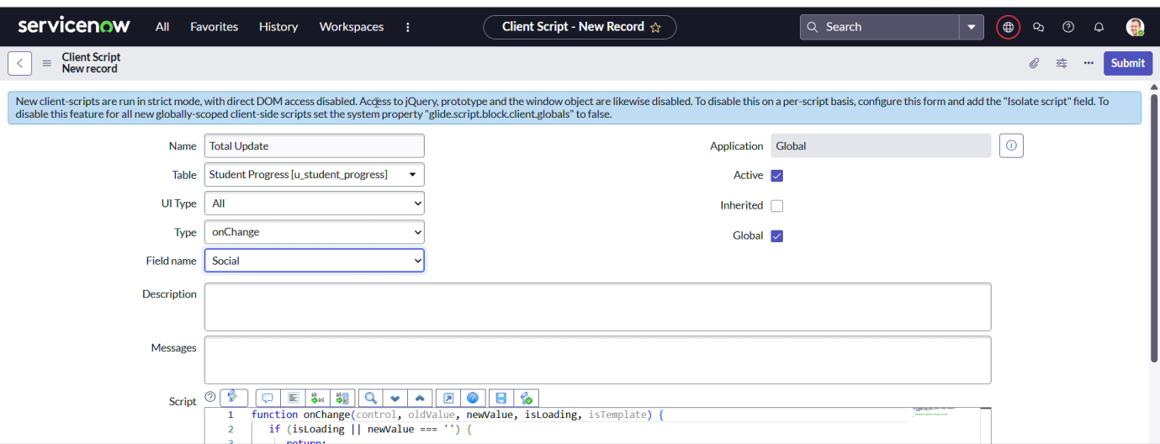

1. Write the Code as below, Enable Isolate script and Save.

function onChange(control, oldValue, newValue, isLoading, isTemplate) {

   if (isLoading || newValue === '') {

return;

   }

   //Type appropriate comment here, and begin script below

if (newValue){

var a = parseInt(g_form.getValue('u_telugu'));

var b = parseInt(g_form.getValue('u_hindi'));

var c = parseInt(g_form.getValue('u_english'));

var d = parseInt(g_form.getValue('u_maths'));

var e = parseInt(g_form.getValue('u_science'));

var f = parseInt(g_form.getValue('u_social'));

var Total = parseInt(a+b+c+d+e+f);

g_form.setValue('u_total', Total);

}

}

1.Fill the Details as given.

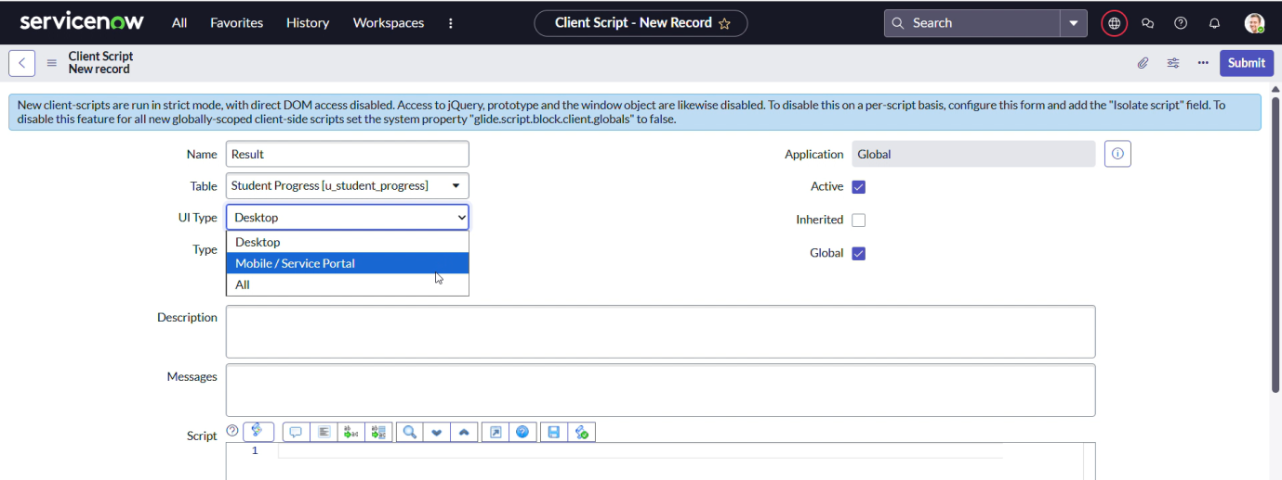

1. Write the Code as below, Enable Isolate script and Save.

function onChange(control, oldValue, newValue, isLoading, isTemplate) {

   if (isLoading || newValue === '') {

      return;

   }

   //Type appropriate comment here, and begin script below

   if(newValue) {

      var a = parseInt(g_form.getValue('u_percentage')); // Convert the value to an integer for comparison

 if(a >= 0 && a <= 59){

         g_form.setValue('u_result','Fail');

      } else if(a >= 60 && a <= 100) {

         g_form.setValue('u_result','Pass');

      } else {

         // Handle the case if a is out of range (optional)

         g_form.addErrorMessage('Percentage should be between 0 and 100.');

         g_form.clearValue('u_result');

      }

   }

}

function onChange(control, oldValue, newValue, isLoading, isTemplate) {

   if (isLoading || newValue === '') {

      return;

   }

   //Type appropriate comment here, and begin script below

   var Total = g_form.getValue('u_total');

  var Percentage = (Total/600)*100;

   g_form.setValue('u_percentage',Percentage+'%');

}

**Milestone 7: Result**

The Educational Institution Management System was successfully developed using ServiceNow. The system streamlines key academic and administrative tasks by providing features such as a student portal, digital ID access, timetable scheduling, and family member login. Users can easily access information, manage academic activities, and stay updated in real time. The solution improves communication, transparency, and operational efficiency within the institution, offering a user-friendly and secure experience for students, staff, and parents.